Carolyn Davidson

**Original painting made by Fredrick George Coltman called *One of the Family***

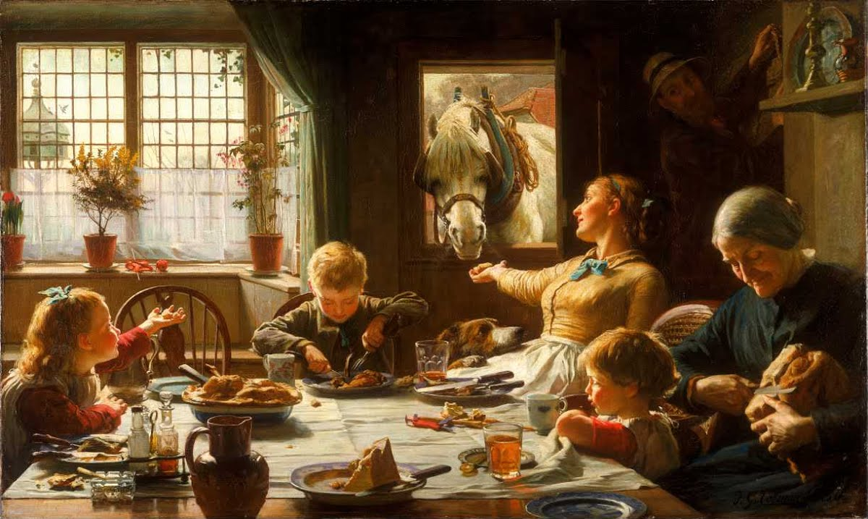

**Our recreated photo of *One of the Family***

